Data labeling tools

* **Label Studio** is an open-source data labeling tool. It lets you label data types like audio, text, images, videos, and time series with a simple UI and export to various model formats. It can be used to prepare raw data or improve existing training data to get more accurate ML models.  
  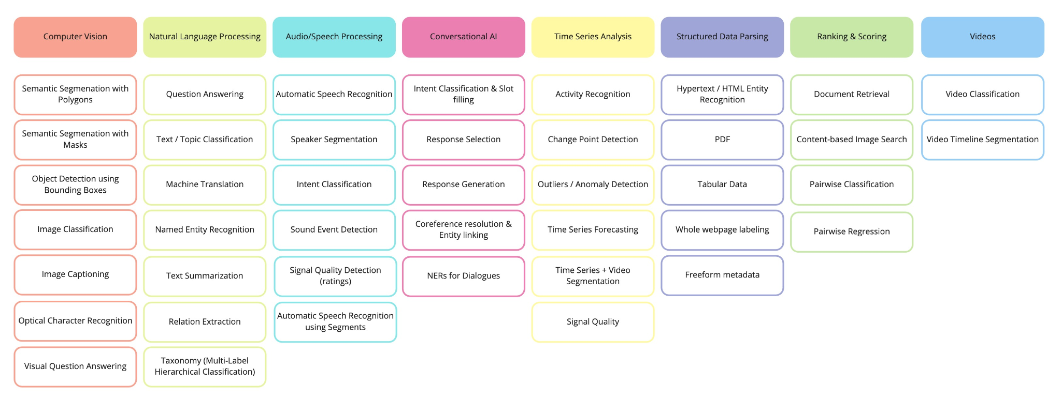  
  + [Label Studio Documentation — Install and Upgrade](https://labelstud.io/guide/install.html)
  + [heartexlabs/label-studio: Label Studio is a multi-type data labeling and annotation tool with standardized output format (github.com)](https://github.com/heartexlabs/label-studio#try-out-label-studio)
* Argilla is a production-ready framework for building and improving datasets for NLP projects.
  + [**Argilla 1.2.1 documentation**](https://docs.argilla.io/en/latest/#)
  + [**argilla-io/argilla: ✨ Open-source tool for data-centric NLP. Argilla helps domain experts and data teams to build better NLP datasets in less time. (github.com)**](https://github.com/argilla-io/argilla)
* **Doccano** is an open-source text annotation tool for humans. It provides annotation features for text classification, sequence labeling, and sequence-to-sequence tasks. So, you can create labeled data for sentiment analysis, named entity recognition, text summarization, and so on.
  + [Doccano](https://doccano.github.io/doccano/) documentation web site
  + [doccano/doccano: Open source annotation tool for machine learning practitioners. (github.com)](https://github.com/doccano/doccano)

Datasets:

* Relation extraction
  + [Relation Extraction | Papers With Code](https://paperswithcode.com/task/relation-extraction)